Welcome to Year 1

[](http://www.clipartbest.com/cliparts/aiq/q8j/aiqq8j7iM.gif)

[](http://www.google.com/url?sa=i&source=images&cd=&cad=rja&uact=8&ved=0CAgQjRw&url=http://www.abcteach.com/documents/clip-art-phonics-e-long-sound-color-26687&ei=ETtNVMSwFKOS7Aaa2YCwCw&psig=AFQjCNGkuW4KIzFiYFg6jUjJRmaXSyGL0A&ust=1414433937434820)







**Year 1**

These are the weekly homework expectations for our class. Most homework is ongoing and reading, phonics practice can happen as often as possible. If specific learning is sent home, this will happen on **Friday** and will need to be back by the following **Thursday**. Reading books should come back to school daily and will be changed when needed.

**Daily**  reading time and phonics

**Daily** phonics reinforcement through reading

This term we are concentrating on 2, 10 x tables, number bonds to 10, doubling to double 10 and +/- 1 to and from numbers to 100.

Reading and Spelling high frequency words as appropriate

Project homework linked to the theme, once every long term (three times a year)

[](http://www.clipartpanda.com/clipart_images/school-supplies-clip-art-1871058)

My maths homework once every two weeks

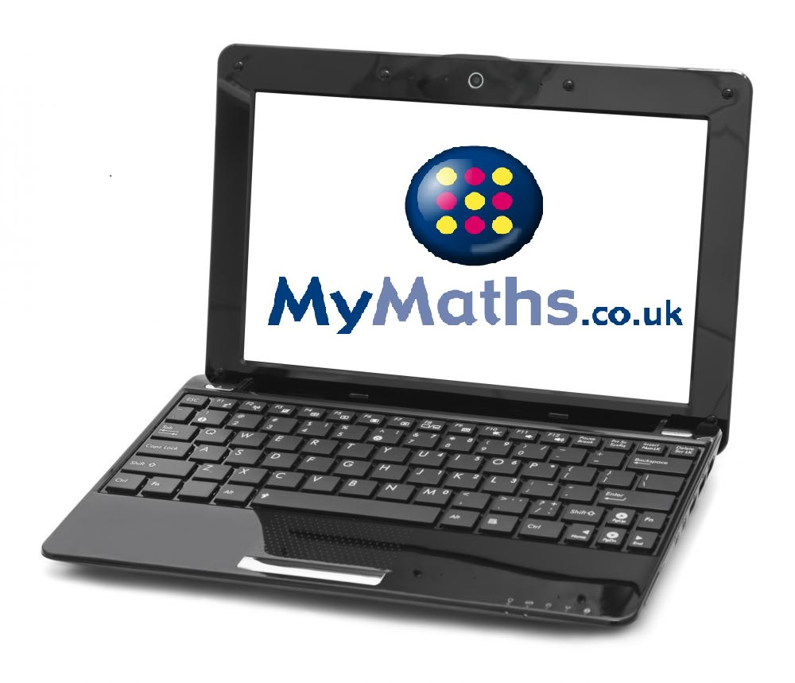

Recommended time:

15 minutes at least 3 - 5 times a week

++