[](https://www.google.com/url?sa=i&url=https%3A%2F%2Fwww.freepik.com%2Ffree-vector%2Fred-coming-soon-neon-icon-vector_3905506.htm&psig=AOvVaw02n0o9sV-Hs8rR3igL0BP3&ust=1585829632850000&source=images&cd=vfe&ved=0CAIQjRxqFwoTCPii-POZx-gCFQAAAAAdAAAAABAD)[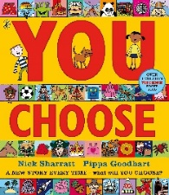](https://www.google.com/url?sa=i&url=https%3A%2F%2Fwww.amazon.co.uk%2FYou-Choose-Pippa-Goodhart%2Fdp%2F0141379316&psig=AOvVaw0yLVKgWgd1W5shMvbIeAUe&ust=1585317709630000&source=images&cd=vfe&ved=0CAIQjRxqFwoTCOjwiOqmuOgCFQAAAAAdAAAAABAD)[](https://www.google.com/url?sa=i&url=https%3A%2F%2Fsinglewhitefemalewriter.wordpress.com%2F2018%2F07%2F11%2Fthe-nine-types-of-book-review%2F&psig=AOvVaw0tzxkM9qXrFJH07mSdwGM3&ust=1585316734637000&source=images&cd=vfe&ved=0CAIQjRxqFwoTCIC-vKGjuOgCFQAAAAAdAAAAABAD)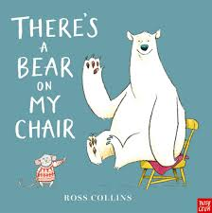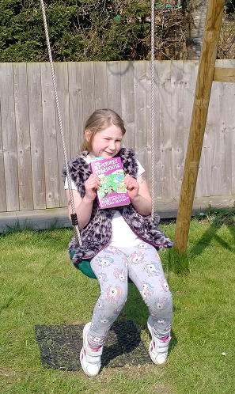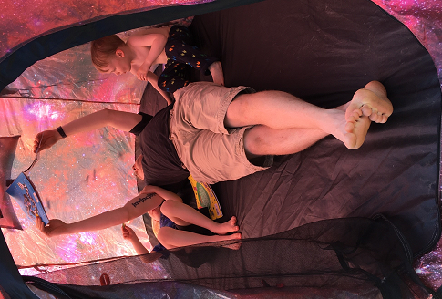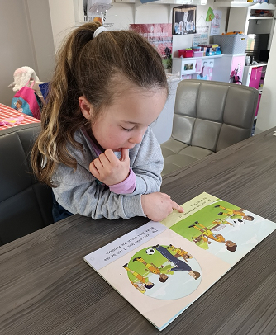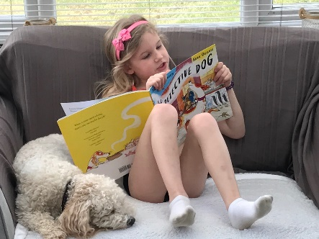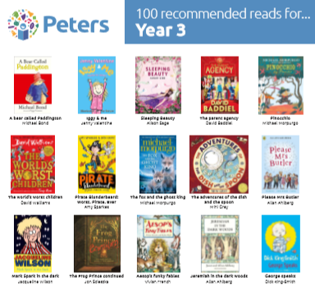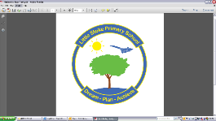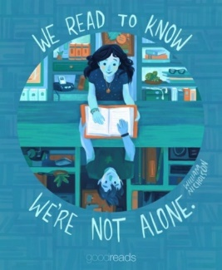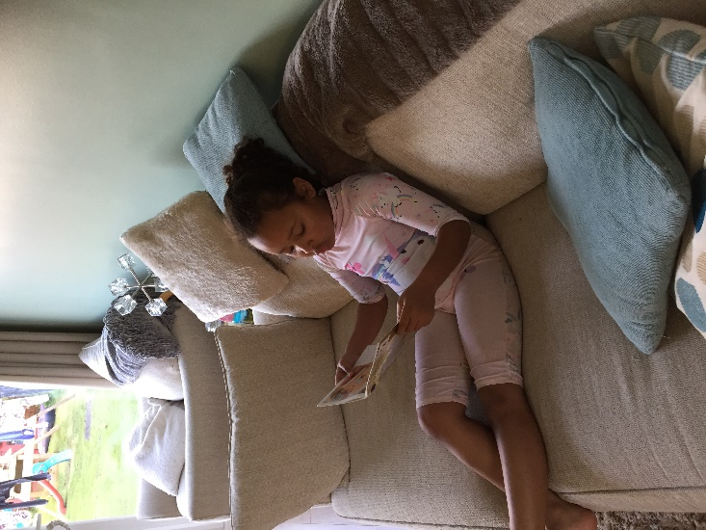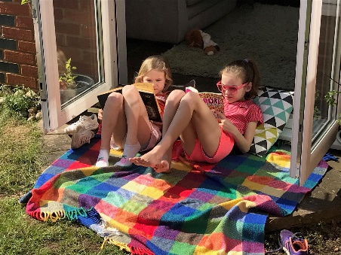 [](https://www.google.com/url?sa=i&url=https%3A%2F%2Flakevieweast.com%2Ftrivia-night%2F&psig=AOvVaw234hYihuryVJQBZyAhECfU&ust=1585315621435000&source=images&cd=vfe&ved=0CAIQjRxqFwoTCJjxx4efuOgCFQAAAAAdAAAAABAD)[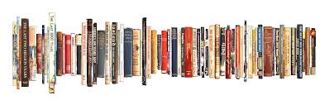](https://www.google.com/url?sa=i&url=https%3A%2F%2Fjocelynbates.com%2Fmy-books%2F&psig=AOvVaw0cCFrgFsh2V6e1N9dhwcyo&ust=1585314929283000&source=images&cd=vfe&ved=0CAIQjRxqFwoTCKDaqL2cuOgCFQAAAAAdAAAAABAY)

**Coming Soon!**

Story time with the staff of Little Stoke. After Easter, we will start sharing an online story time with staff reading some of our favourite books for you to enjoy! Watch this space for more details!

**Your Next Favourite Book**

Peter’s the book seller has released the top 100 books for each year group across the primary age range. There’s some great ideas if you are looking for a new read to share together.

<https://peters.co.uk/100-books-for-every-year-group-primary>

This week’s review is for You Choose by Nick Sharratt. Although there isn’t much reading in it, there’s lots and lots of pictures to talk about. As a family, we discuss which choices we would make on each page including what we’d choose to wear, where we’d choose to live and who we’d want for our family and friends. Each page is filled with amazing illustrations that with lots of detail. There are others in the same range including You Choose Your Dreams and You Choose in Space. Once you’ve read them, children could make their own pages drawing different types of houses, animals or people.

It’s great to see people enjoying a good book at home! Please keep sending it photos to [admin@littlestokeps.co.uk](mailto:admin@littlestokeps.co.uk) and we’ll share them here.

**Share a story and have some quiet time!**

Don’t forget to check out the listen to stories links. Cbeebies has a host of stories read by celebrities including Tom Hardy reading There’s a Bear in My Chair. It’s an ideal opportunity for children to enjoy a story and for parents to have some quiet time.

Why not sit down and research these questions? Perhaps you’ll come across some other interesting book facts that you could share with us!

1. What do the books Winnie the Pooh, The Hobbit and the Tiger Who Came to Tea all have in common?
2. What is the most successful Children’s book (the one that sold the most copies)?
3. What was Dr Seuss’ real name?

Well it’s been just over a week since the schools closed and the country entered lockdown. We hope everyone is adjusting to their new lives at home and their home schooling!

This is the first of our regular reading newsletters which will hopefully give you some fun ideas of things you can be doing while you’re at home.

Chatter Books