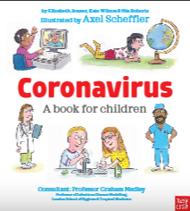[](https://www.google.com/url?sa=i&url=https%3A%2F%2Febookfriendly.com%2Fbest-quotes-books-reading%2F&psig=AOvVaw3Z1U-2_WkCH-NZRoYa5uQc&ust=1586955346129000&source=images&cd=vfe&ved=0CAIQjRxqFwoTCKis1Mb75-gCFQAAAAAdAAAAABAD)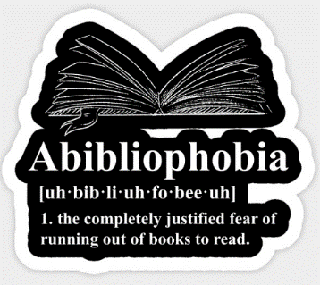[](https://www.google.com/url?sa=i&url=https%3A%2F%2Fwersm.com%2Ffacebook-launches-know-feature-tbhs-popularity-tanks%2F&psig=AOvVaw2PHX7ELFALQoZFcYOGz7Je&ust=1587555801076000&source=images&cd=vfe&ved=0CAIQjRxqFwoTCOCwu7K4-egCFQAAAAAdAAAAABAD)[](https://www.google.com/url?sa=i&url=https%3A%2F%2Fsinglewhitefemalewriter.wordpress.com%2F2018%2F07%2F11%2Fthe-nine-types-of-book-review%2F&psig=AOvVaw0tzxkM9qXrFJH07mSdwGM3&ust=1585316734637000&source=images&cd=vfe&ved=0CAIQjRxqFwoTCIC-vKGjuOgCFQAAAAAdAAAAABAD)[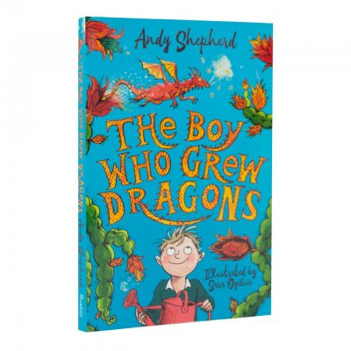](https://www.google.com/url?sa=i&url=https%3A%2F%2Fwww.waterstones.com%2Fbook%2Fthe-boy-who-grew-dragons%2Fandy-shepherd%2Fsara-ogilvie%2F9781848126497&psig=AOvVaw19gYUnn2gQiEOvESzng8uQ&ust=1587735477094000&source=images&cd=vfe&ved=0CAIQjRxqFwoTCNCdu9zV_ugCFQAAAAAdAAAAABAD)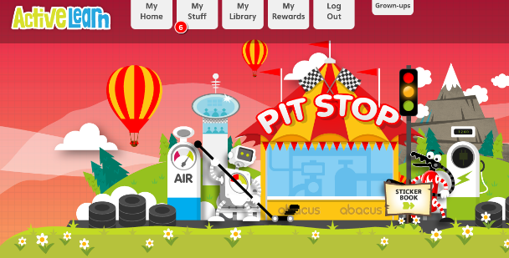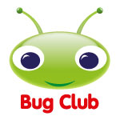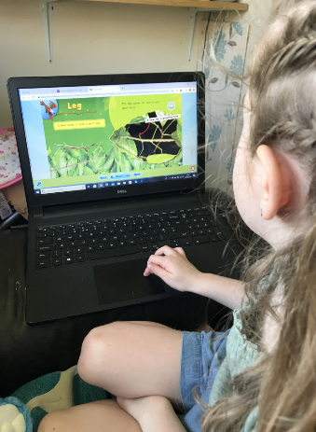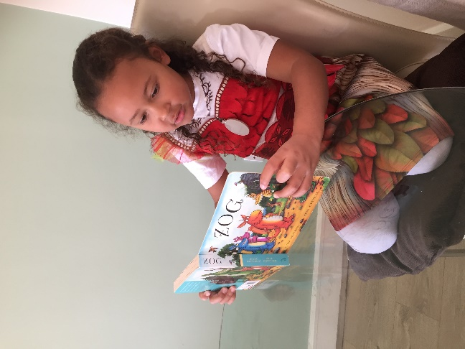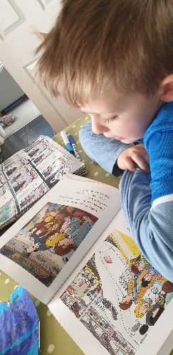[](https://www.google.com/url?sa=i&url=https%3A%2F%2Flakevieweast.com%2Ftrivia-night%2F&psig=AOvVaw234hYihuryVJQBZyAhECfU&ust=1585315621435000&source=images&cd=vfe&ved=0CAIQjRxqFwoTCJjxx4efuOgCFQAAAAAdAAAAABAD)[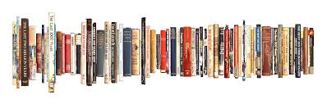](https://www.google.com/url?sa=i&url=https%3A%2F%2Fjocelynbates.com%2Fmy-books%2F&psig=AOvVaw0cCFrgFsh2V6e1N9dhwcyo&ust=1585314929283000&source=images&cd=vfe&ved=0CAIQjRxqFwoTCKDaqL2cuOgCFQAAAAAdAAAAABAY)

We hope you all had an excellent Easter and enjoyed chocolate, hot cross buns, sunshine and plenty of reading. There’s lots of new exciting developments to inform you of in our second Chatter Books.

A great new resource has been released in the last few weeks which can help anyone who is finding it tricky to answer your children’s questions about Coronavirus. Axel Scheffler who illustrates Julia Donaldson’s books and writes his own including the Pip and Posy series, has released a book which addresses some of the common questions children may have. It is PDF that can be downloaded for free from [www.nosycrow.com](http://www.nosycrow.com)

Abiliophobia is the fear of running out of books to read. Now we have Bug Club you have no need to suffer from this again!

This week’s review is for The Boy Who Grew Dragons. This book is ideal for key stage 2 children who like fantasy stories with a bit of a comic twist! The story focuses on Tomas who, when working on the allotment with his grandad, finds a dragon fruit tree and a dragon fruit begins to glow. After taking it home, a dragon hatches from the fruit. The rest of the story is about him learning how to take care of his dragon (Flicker) whilst keeping it a secret from his family and friends. Imagine how you would feel in this situation – would you be up to the challenge?

**Please send your reviews in to us and see them included here!**

We are very excited to announce that we now have access to Bug Club. This is a fantastic, and usually very expensive, online reading platform which will give you access to reading books at home!

You can read colourful, exciting new books, complete quizzes about them, collect points and collect rewards. Once you’ve read your books, your teachers will be able to set you new ones just like when you change your book at school. It’s a great resource which we are very excited to have free access to.

Login details will be emailed out by April 24th! If there are any issues let us know.

Make sure you make the most of it ☺

The Open University has released a great flow diagram which explains more about how you can develop reading and a love of booksas a family. It has some great ideas on it and is worth a look. A large version is attached.

It’s great to see people enjoying a good book at home! Please keep sending it photos to [admin@littlestokeps.co.uk](mailto:admin@littlestokeps.co.uk) and we’ll share them here.

Chatter Books

Answers from the last Chatter Books

1. Winnie the Pooh, The Hobbit and the Tiger Who Came to Tea all started as stories the authors made up to tell their children.
2. Harry Potter is the best-selling children’s book series having sold 500 million copies world-wide.
3. Dr Seuss’ real name was Theodor Seuss Geisel.