Curriculum Statement
At Little Stoke Primary, we aim to provide an exciting, engaging, knowledge-rich curriculum which will inspire in children a love of learning. We believe the driving force of a high quality, creative and broad curriculum is a clear focus on delivering excellent teaching and learning. This will ensure children engage in a range of learning experiences that are challenging, embedded in links with real life and meaningful experiences. This in turn enriches the education experiences of all children and motivates them to invest in a journey of lifelong learning which can be nothing less than life changing.
Learners at Little Stoke will make this journey in different ways but teachers will place consistent emphasis on resilience, collaboration and participation. Our curriculum is designed to provide the building blocks of deepening knowledge so that, at every stage, children will build on the knowledge they already have. They will deepen their understanding by using this knowledge in different contexts and will be supported to make links and build connections between areas of learning. We believe developing children’s oracy skills is vital to allow them to progress and achieve in other areas of the curriculum and foster respectful and productive relationships with peers and adults alike. Teachers plan to develop spoken language skills through discrete oracy sessions and interweave the skills through the whole curriculum, in the process creating classrooms that are rich in talk. The cognitive benefits of oracy are reflected in the robust evidence that quality classroom talk has a measurable impact on academic attainment (Alexander 2012). These benefits include greater retention of subject-specific knowledge, vocabulary acquisition, and reasoning skills and can be seen throughout the curriculum.
Little Stoke Primary School is committed to meeting the requirements of the National Primary Curriculum in a challenging but holistic way with inclusion at the heart of all we do. Learning is connected by careful teacher planning of progression to meet the ever-changing needs of the pupils both in school and out of school and it is geared towards creating successful 21st century citizens who aspire to become the best they can be whist also ensuring they have appositive impact on the world and become positive global citizens. We aim to foster inquiring minds, logical reasoning, and collaboration to prepare them for a world where skills in science, technology, engineering and maths (STEM) are increasingly important. As such, STEM subjects and opportunities linked to them are highly regarded within our curriculum and aim to provide exciting opportunities to enthuse and inspire children to develop their understanding in these areas.
Facilitated through our fantastic outdoor spaces, outdoor learning, and in particular Forest School, are a regular feature of our curriculum that not only enhance the lessons developed by teachers but more importantly support and nurture children’s social skills and self-confidence. Our Forest School sessions develop risk taking, independence, resilience and self-awareness for all children. They foster curiosity and allow all children to thrive in a different setting whilst also providing them with vital knowledge and skills to become aware of sustainable living.
Our enquiry-based curriculum is enhanced with enriching opportunities that make up the wider school curriculum. Learning is always exciting, sequenced logically to allow children to make connections with prior learning and set in logical contexts for the children with plenty of meaningful opportunities to rehearse, use and deepen their understanding, building on strong foundations of prior knowledge.
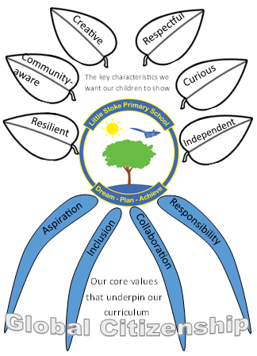

Curriculum Intent (WHAT & WHY)

Aspiration
The developing expectation that you will be able to achieve significant goals
Collaboration
The co-operation and teamwork and the sharing of ideas, knowledge and skills to reach a common objective
Responsibility
The ability and confidence to self-regulate and take care of yourself, other, the community, the world and the future
Inclusion
The ability to show empathy towards others and strive to ensure that all children are included and difference is celebrated
Our underlying curriculum values
Will develop...
Resilient children who
persevere when faced with a challenge and bounce back from potential failure
Community-aware
children who support their local community and understand the challenges faced by different people and places
Curious children who show a desire to learn and have the enthusiasm to explore and figure things out
Creative children who have the ability to imagine and create a new idea drawing from a range of knowledge
Respectful children who are kind and treat other people and things how they would like to be treated
Independent children who take care of themselves, self-regulate and problem-solve

The key
characteristics we want see in our children
Global Citizenship
The curriculum we have developed at Little Stoke is a knowledge-based curriculum that is strategically sequenced to allow learners to build on prior knowledge utilising carefully planned links within and between units. It resembles a 3D curriculum (Sealy, 2017) which has deliberately constructed vertical, horizontal and diagonal links. Learners will develop connections between schemas, which will allow them to make links to prior knowledge that is stored in long-term memory. By creating a coherent curriculum with links across year groups, units and subjects schema will develop. As schema develop they become stronger and allow more links to be made which then makes it easier to retrieve the information from long-term memory.
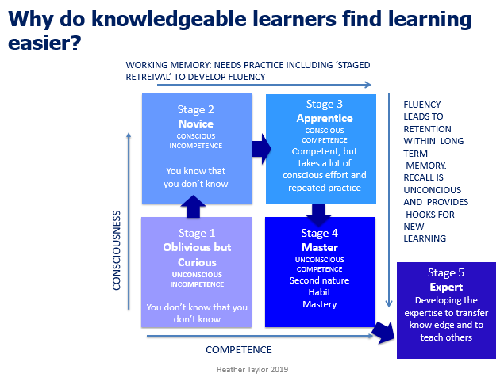

By creating a knowledge-based curriculum, this will allow learners to free up working memory by using schema to draw on knowledge stored in their long-term memory. This will allow them to use their working memory to develop cognitive skills. ‘Higher-order thinking is knowledge-based: The almost universal feature of reliable higher-order thinking about any subject or problem is the possession of a broad, well-integrated base of background knowledge relevant to the subject.’ ​(E D Hirsch, 1996). Children will develop skills as a by-product of acquiring the knowledge. For example, children will learn the knowledge around how to develop a practical scientific experiment and then put this into practise using the knowledge to develop the skills needed to conduct the experiment. ‘Knowledge and skill are intrinsically linked: skill is a performance built on what a person knows.’ (Spielman, 2018).
We have developed a thematic curriculum that is based around knowledge acquisition, as we believe a knowledge-rich curriculum will help to combat educational inequality. The more a pupil knows, the more they are able to learn and understand. As previously mentioned our curriculum has deliberate links that are highlighted by teachers.

Picture of overview to be inserted showing links

Assessment/Spaced retrieval
New learning can be fragile and we know it is important to revisit and refresh this knowledge regularly to ensure it becomes embedded in the long-term memory, thus making it possible for a pupil to retrieve in the future. Sealy suggests that a child’s memory gets stronger if they have had chance to ‘forget a bit’ as they have to work harder to ‘find’ the information. The more a child searches for knowledge the easier it then becomes to find on subsequent attempts. As a school, we used spaced retrieval at carefully planned stages to ensure children have the chance to recall the knowledge. We recognise that it is important for them to attempt to recall their knowledge independently as this strengthens the schema. If a child cannot recall, then the knowledge has not been retained and it will need to be re-taught. ‘If nothing has been retained in long term memory then nothing has been taught.’ (Kirschner, Sweller & Clark, 2006).
At the end of a unit, children will take part in a knowledge transfer activity where they will share the knowledge they have learned with others. This may be through, but not exclusive to, a class assembly, parent event or an activity with another class.

