Little Stoke Primary School – School Development Plan 2020-2021 – Parent Summary
Teaching and Learning
English  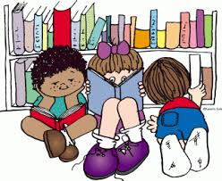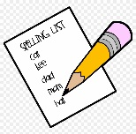 | Maths  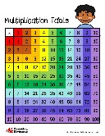 | 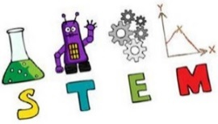  STEM | Behaviour and Attitudes  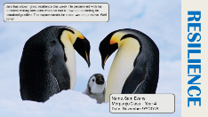
- We are working to make our teaching of reading and writing more engaging, particularly for boys.  - We are developing the use of non-fiction books in reading and writing.  - We will continue to develop our spelling teaching. | - We are working on improving the children’s speed and effectiveness of key mental calculation skills.  - We are continuing to work on improving the children’s times tables knowledge and speed.  - We are developing the children’s accuracy when using appropriate written methods. | - We will continue to establish effective assessment systems for Science and Computing.  - We are working to purchase and embed coding and engineering technology into the curriculum.  - We will ensure that online safety is fully integrated across the curriculum. | - We will help children to develop strategies to regulate their behaviour.  - We will continue to embed behaviour strategies across the school with a focus on consistency. We will continue to take part in the Better Behaviour Project that is run by the local authority.  - We will help to develop the children’s skills needed for learning.
Personal Development | Leadership, Management and Governance | EYFS | Pupil Premium  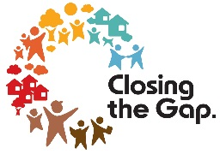
- We will ensure work is done to successfully reintegrate children back into school.  - We will being to implement and refine our new curriculum, ensuring it is relevant to the children at Little Stoke.  - We will ensure the curriculum is accessible for all children.  - We will continue to develop the use of oracy across the school and across the whole curriculum. | - We will form curriculum leadership groups to develop and improve our curriculum.  - We will continue to develop and embed our new school assessment structures. | - We will develop our oracy skills and link these into our learning.  - We will offer many opportunities for parents to engage with their child’s learning – in particular around speech and language development.  - We will being to develop strong relationships with Little Apples – the new pre-school that sue our site. | - PP children will achieve better than expected progress through high quality strategies and interventions.  - We will continue to support families on a range of matters through our family and pastoral worker.

