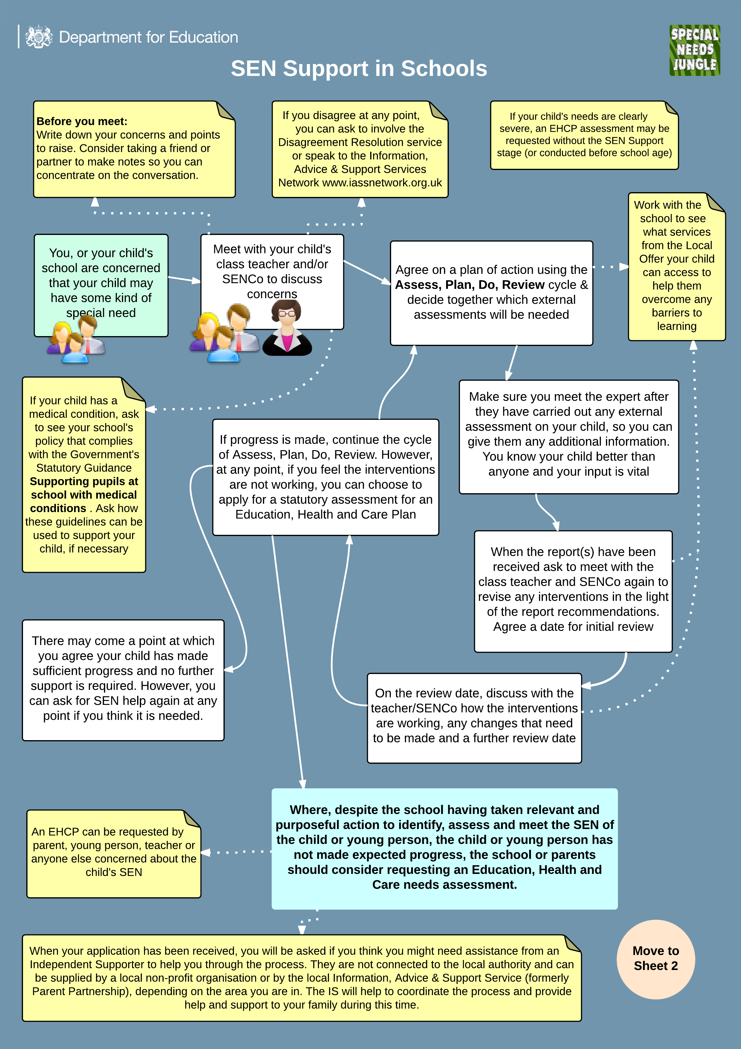
SEND Support in School
Our procedures will follow the guide below. If you would like support, do ask to speak to Mrs Tyson our Special Educational Needs Coordinator.(SENDCo)

